FULL CAPSTONE REPORT

1. Executive Summary

This project simulates a full red team engagement in a controlled lab environment to evaluate system security and detection capabilities. The objective was to emulate a real-world cyber attack from reconnaissance to data exfiltration while analyzing blue team visibility.
The engagement began with reconnaissance using Recon-ng to identify target assets. Initial access was achieved through a simulated phishing payload generated with Metasploit and delivered to the target system. Upon execution, a reverse shell was established, providing remote access.
Post-exploitation activities included system enumeration, privilege context validation, and file access. Sensitive data was exfiltrated from the compromised system. Additionally, evasion techniques were tested using a basic obfuscated payload.
From a defensive perspective, Wazuh logs were analyzed to identify detection points. Alerts related to agent activity and system behavior provided insight into monitoring effectiveness.
The results demonstrate how weak security controls, insufficient monitoring, and user susceptibility to phishing can lead to full system compromise. This project highlights the importance of detection mechanisms, endpoint security, and user awareness in preventing such attacks.

2. Attack Phases Log Table

Phase | Tool Used | Action Description | MITRE Technique
Recon | Recon-ng | Target discovery / enumeration | T1595
Initial Access | Metasploit | Phishing payload delivery | T1566
Exploitation | Metasploit | Reverse shell execution | T1203
Post-Exploitation | Meterpreter | System enumeration | T1082
Credential/Access | Meterpreter | User/session info | T1033
Exfiltration | Meterpreter | File download (hosts) | T1041
Defense Evasion | msfvenom | Payload generation | T1027

3. Attack Narrative

Reconnaissance
Target information was gathered using Recon-ng to identify systems within the lab network.
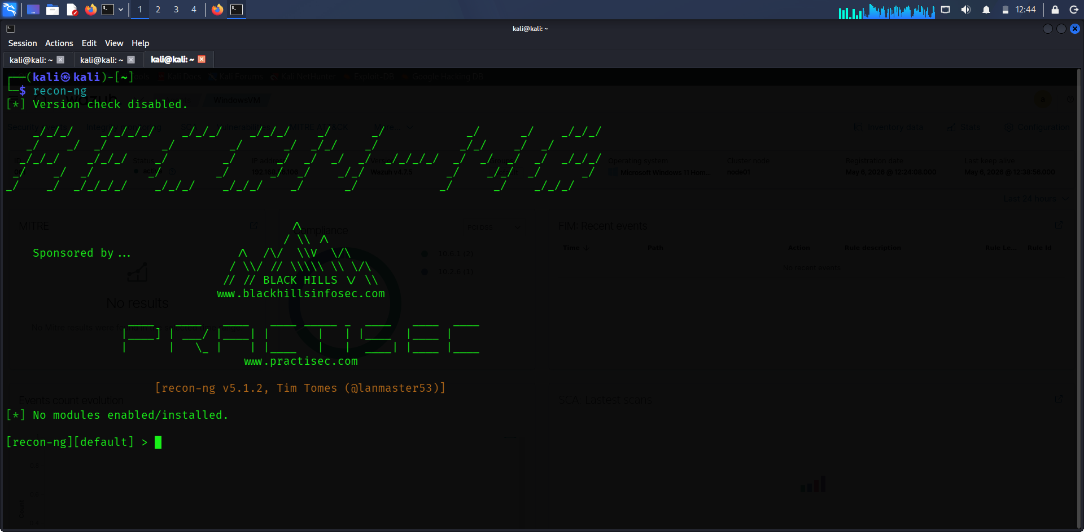
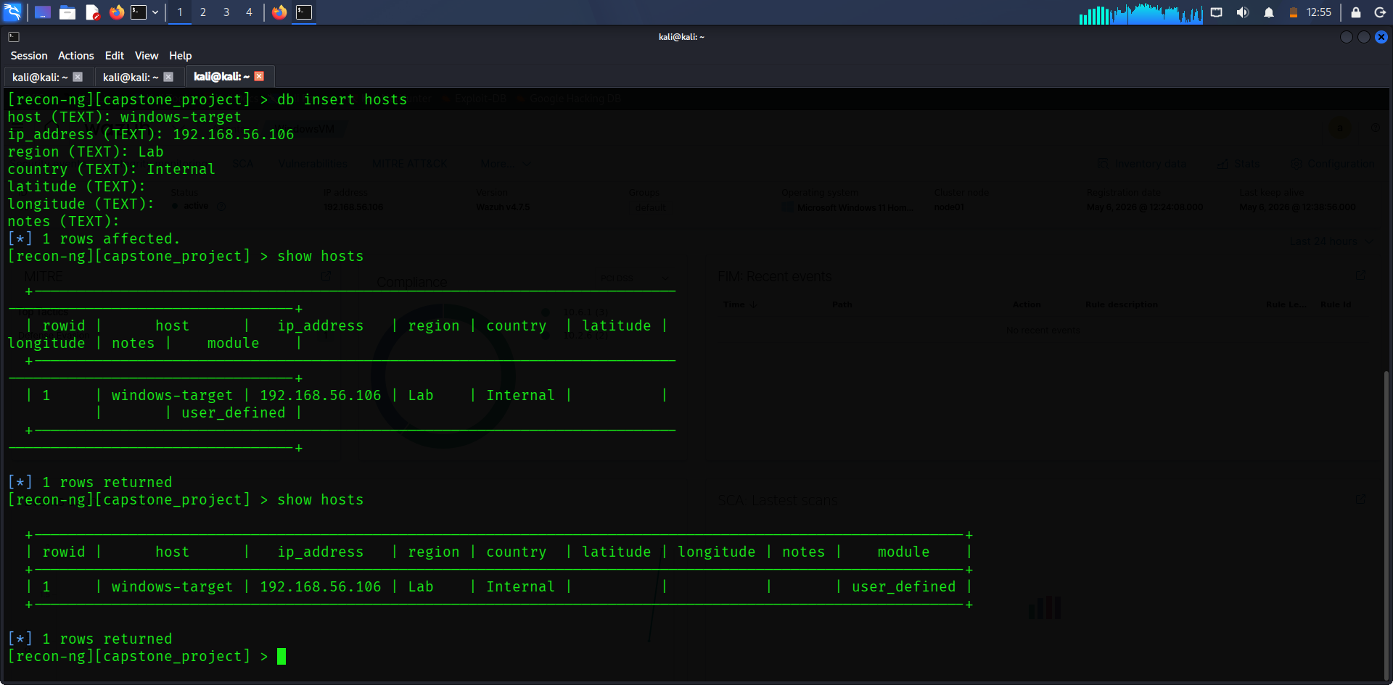

Initial Access (Phishing Simulation)
A malicious payload (invoice.exe) was generated and delivered to simulate a phishing attack.
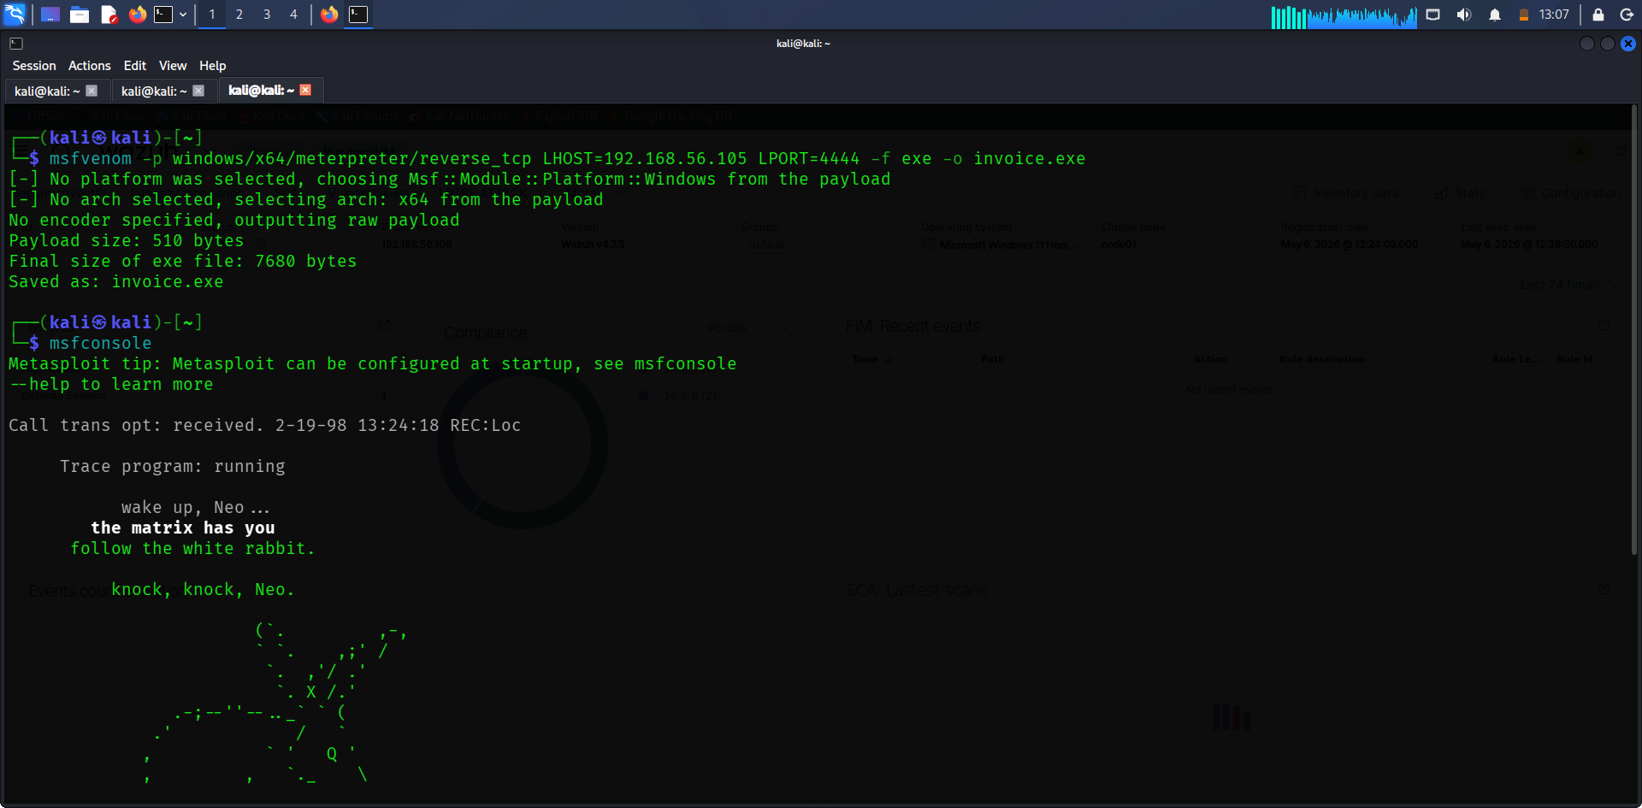
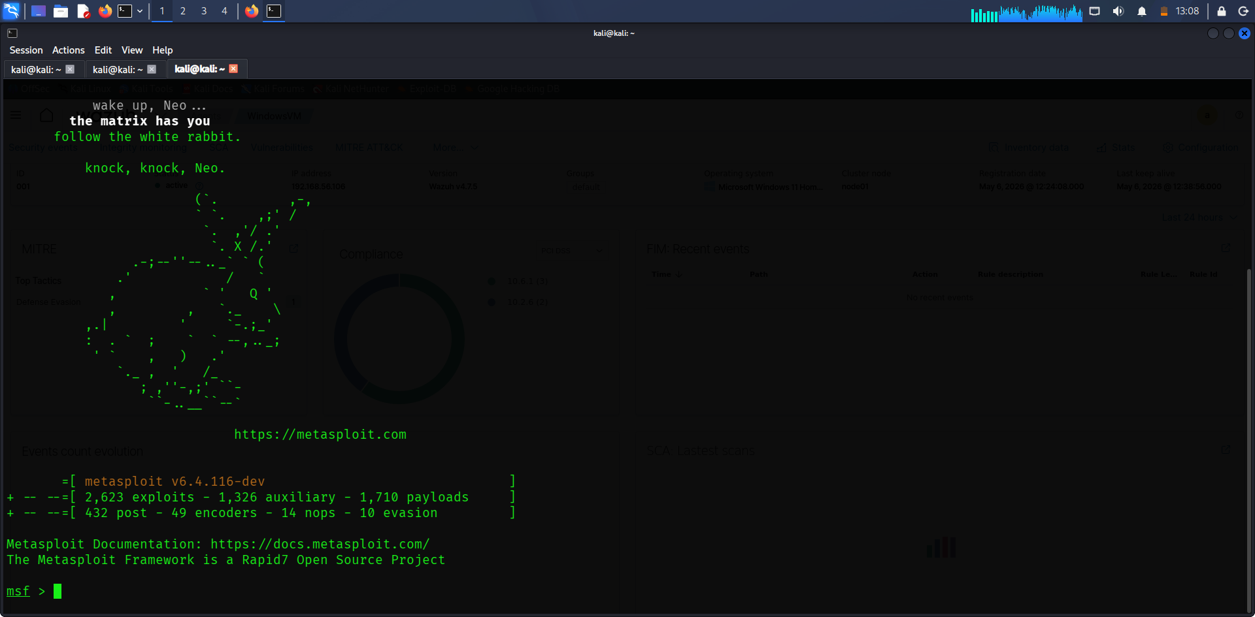

Exploitation
A reverse TCP handler was configured, and a Meterpreter session was successfully established.
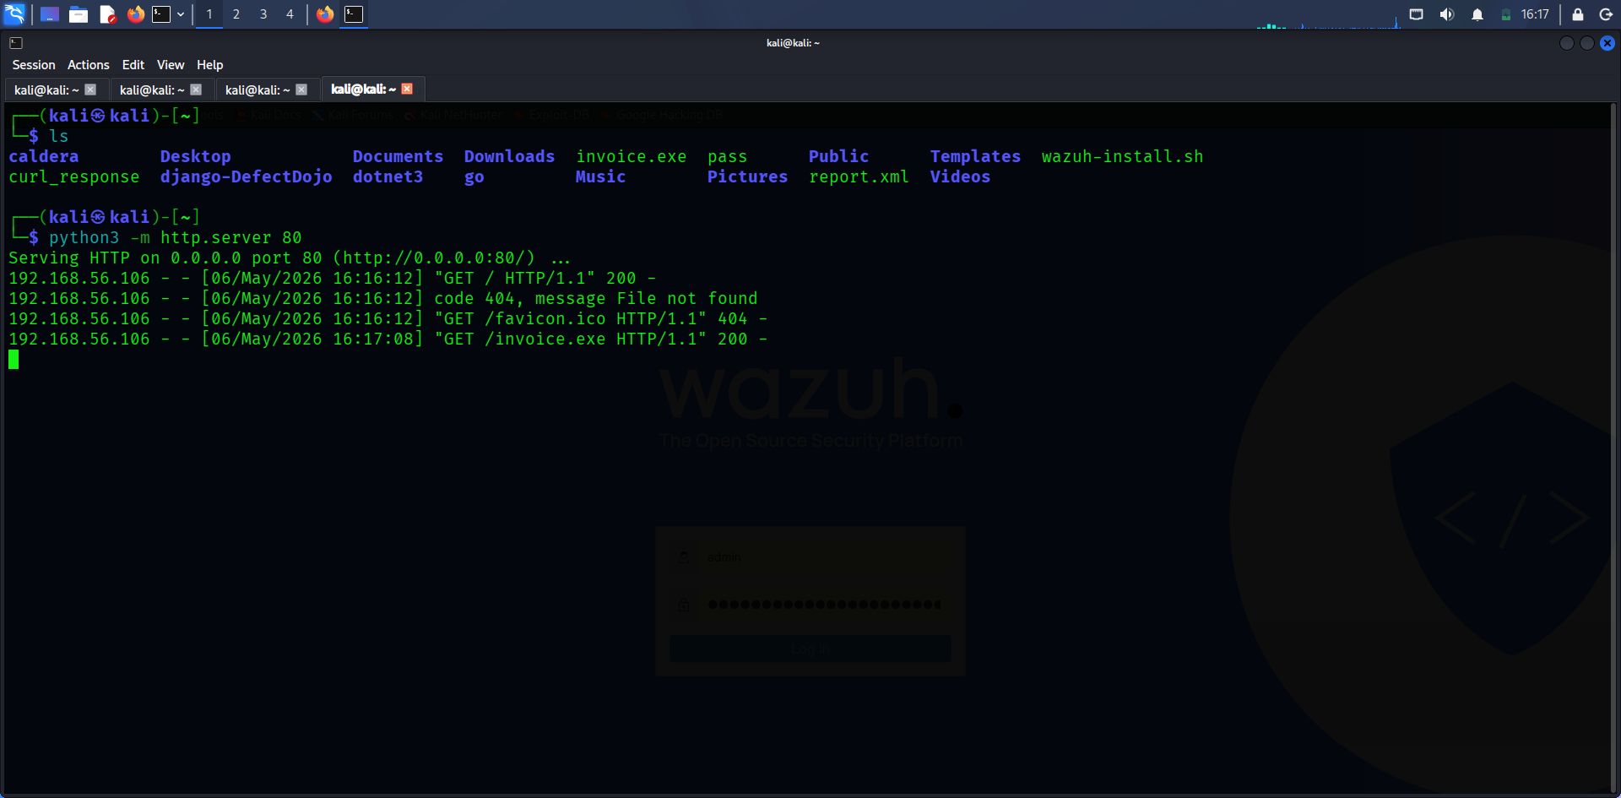
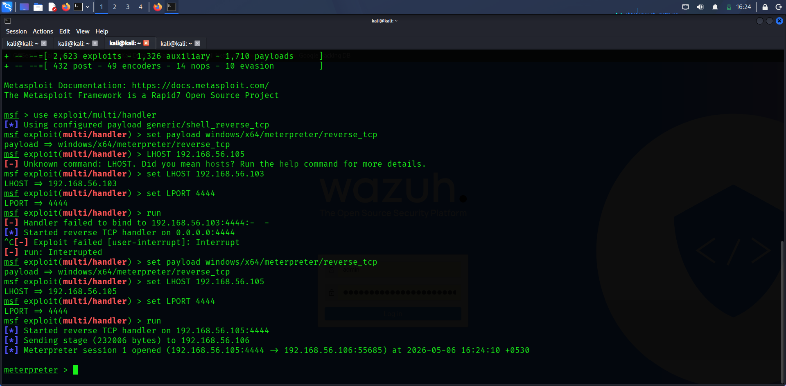

Post-Exploitation
System information such as OS version, user, and directories was enumerated.
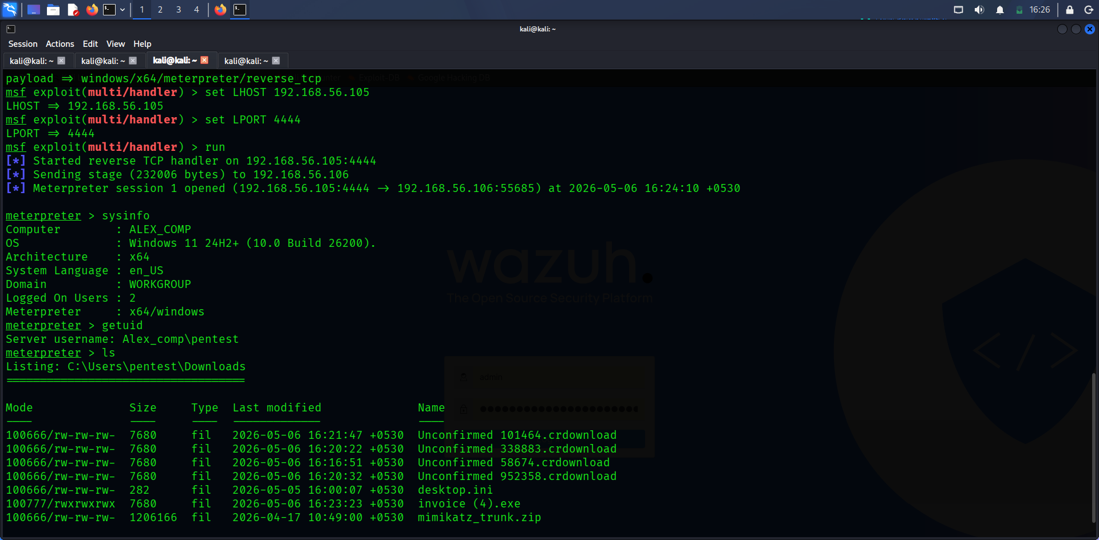

Data Exfiltration
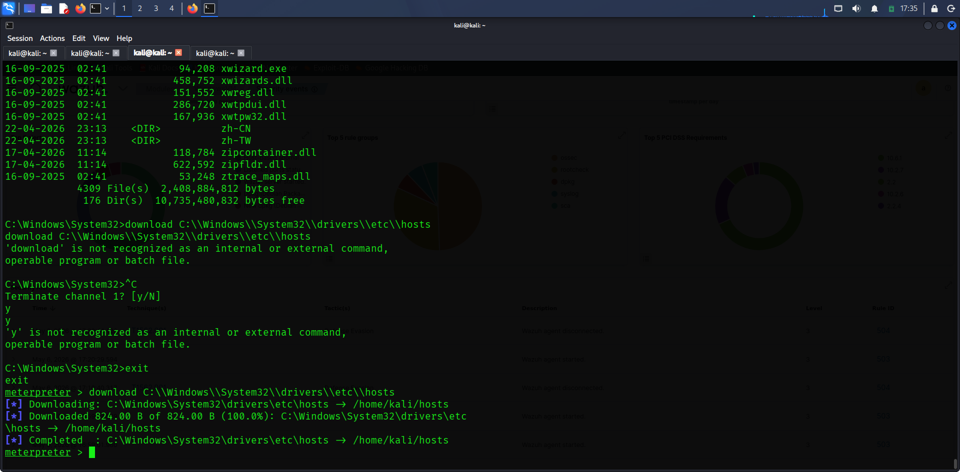
Sensitive system file (hosts) was extracted from the target machine.

4. Blue Team Analysis (Wazuh Logs)
Timestamp | Alert Description | Source IP | Notes
May 6, 2026 | Agent disconnected | 192.168.56.106 | Possible evasion activity
May 6, 2026 | Agent started | 192.168.56.106 | Service restart
May 6, 2026 | System activity spike | 192.168.56.106 | Post-exploitation activity

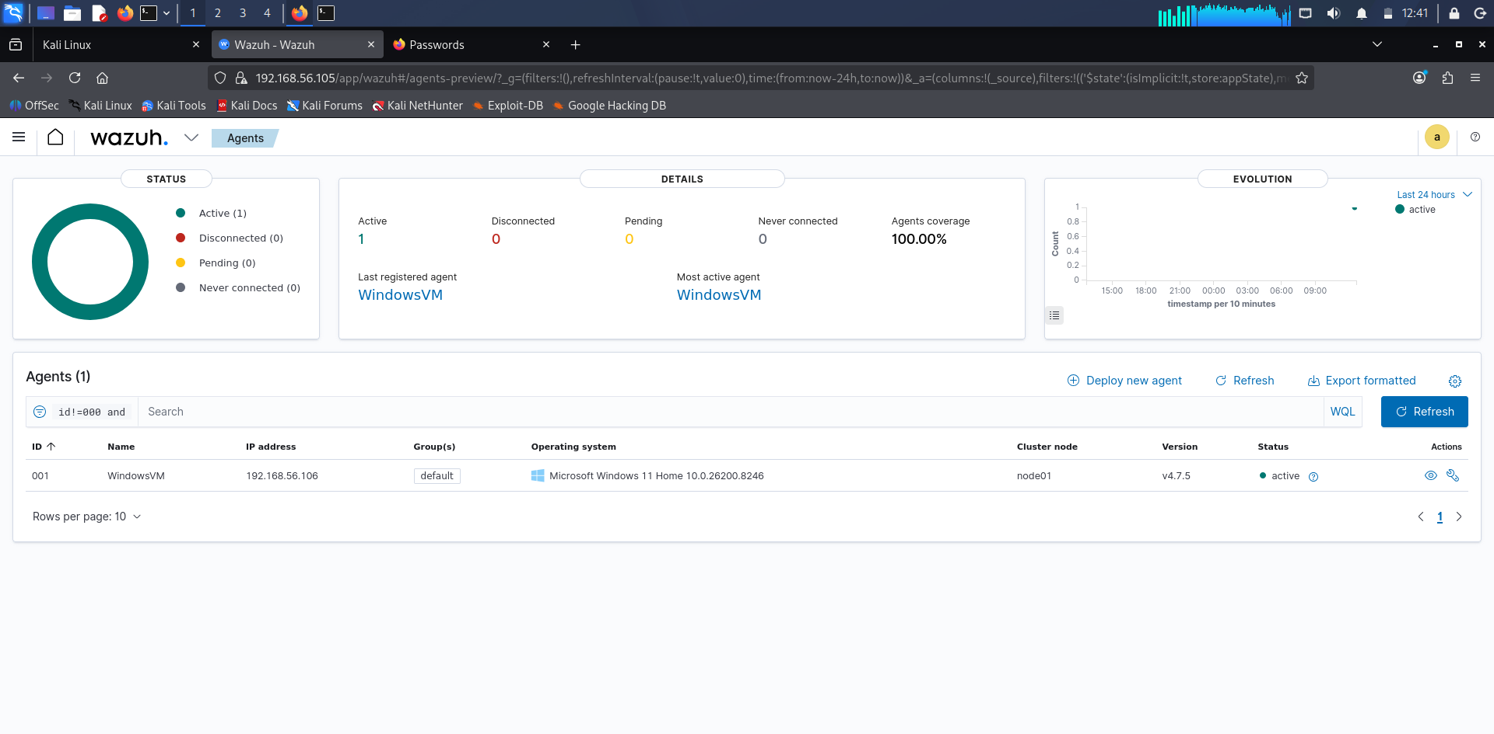
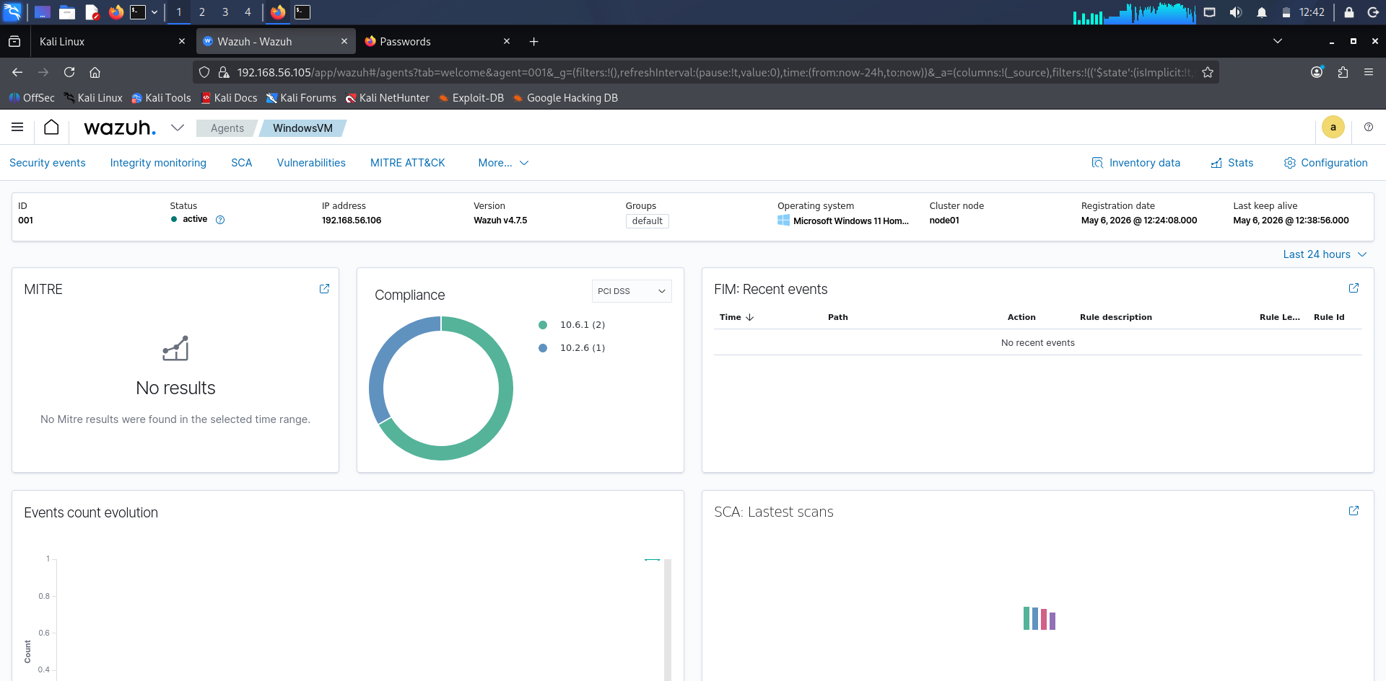
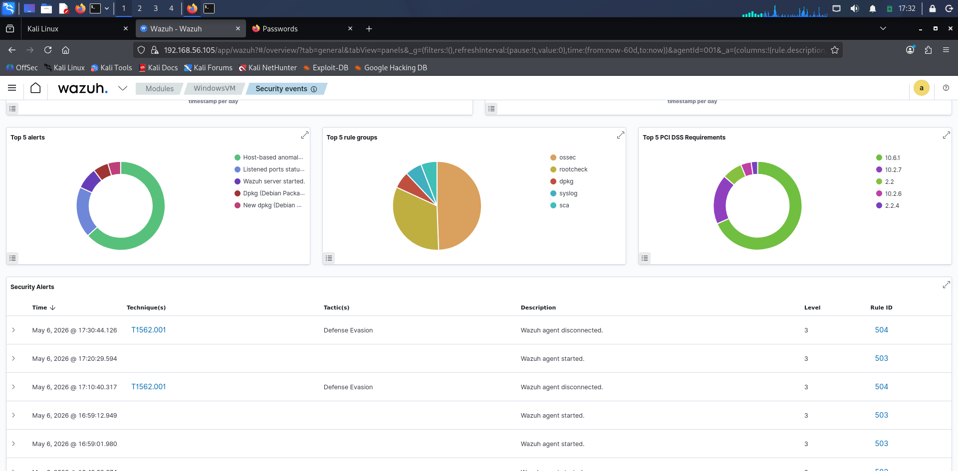

5. Evasion Testing

A payload was generated using msfvenom to simulate basic antivirus evasion through encoding/obfuscation.

6. Findings
- Weak endpoint protection allowed payload execution
- No effective phishing detection mechanism
- Limited visibility into post-exploitation behavior
- Wazuh detected some activity but lacked full correlation
- Lack of network segmentation increased risk

7. Recommendations
- Implement phishing awareness training
- Deploy EDR solutions for endpoint monitoring
- Enable real-time alerting and correlation
- Improve network segmentation
- Monitor process execution and unusual binaries
- Enhance log analysis and SIEM rules

8. Non-Technical Briefing

This project demonstrated how a cyber attacker can gain access to a system through a simple phishing attack and then take full control of it. Once inside, the attacker was able to gather information, access sensitive files, and transfer data outside the network.
Although some suspicious activity was detected, the monitoring system did not fully prevent the attack. This highlights the importance of stronger security measures, better monitoring, and user awareness training.
Improving these areas can significantly reduce the chances of similar attacks and help protect critical systems and data.

